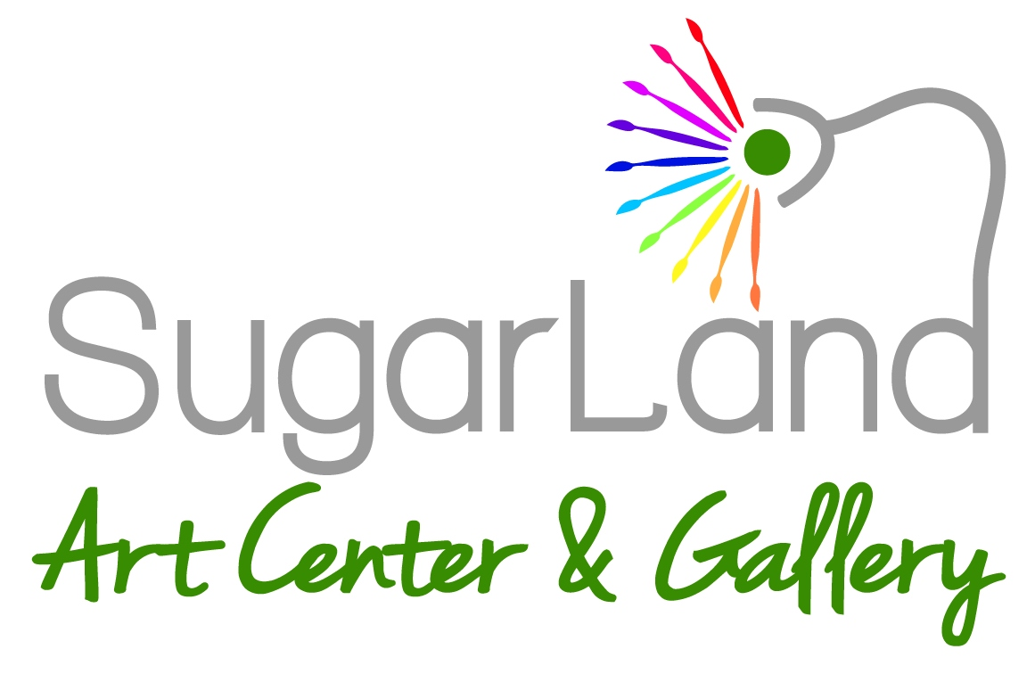
Volunteer Application
Kids Art Camp & Kids Lego Camp

Name: _____________________________________________________________________Birthdate:_______________

Address: ______________________________________________Phone:_______________________________________

______________________________________________Email:________________________________________

Parent/Guardian Information:

Names: ________________________________________________________Phone:______________________________

Email: _____________________________________________________________________________________________

Week / Shift (AM or PM) You Are Interested In: ___________________________________________________________

Why do you want to volunteer with us: __________________________________________________________________

__________________________________________________________________________________________________

Have you done any volunteer work in the past? Please explain: _______________________________________________

__________________________________________________________________________________________________

Do you need a letter of recommendation or letter of credit hours? If so, for what school or organization are you affiliated with?

__________________________________________________________________________________________________

Do you have any allergies or medical concerns that we should be aware of: _____________________________________

__________________________________________________________________________________________________

Are you an Art Student? ______ Would you be interested in an Internship program during the school year?________

If so, How long have you been an art student, where have you studied, and what are your goals in pursuing art as a career? _________________________________________________________________________________________
________________________________________________________________________________________________

Please continue your application on the back

104 Industrial Blvd. Ste. Q Sugar Land, TX 77478 281-565-0957 www.sugarlandartcenter.org
-------------------------------------
LIABILITY WAIVER
-------------------------------------
I, ___________________________________________ release and hold harmless the Sugar Land Art Center & Gallery, its employees, students and agents from any and all liability for any loss, damage, injury or expense that I or my next of kin may suffer as a result of my participation in any and all classes provided by the Sugar Land Art Center & Gallery, including but not limited to, accidents, acts of God, war, civil unrest, sickness, terrorism, transportation, scheduling, government restrictions or regulations and any and all expenses I may incur while participating in the program. I understand this agreement cannot be modified except in writing by the school and that no oral modification or interpretation shall be valid.

I give permission for pictures of myself or next of kin taken in classes to be used for publicity in the newspapers, website or on brochures for next year. ______yes ______no (please initial)

I allow Sugar Land Art Center & Gallery’s teaching staff to notify me of other upcoming learning opportunities.

I have read this document carefully and I acknowledge my responsibilities and the effect of this liability waiver.

_______________________________ ___________________________________
Print Name Signature
______________
Date

Sugar Land Art Center & Gallery is a non-profit 501c3. We are only able to maintain our organization thru our gracious volunteers. We greatly appreciate your time and willingness to help make Sugar Land Art Center a better place!
THANK YOU!

104 Industrial Blvd. Ste. Q Sugar Land, TX 77478 281-565-0957 www.sugarlandartcenter.org

